

**FWILKINSON GARDENS**

**ELEMENTARY**

**STUDENT AND PARENT HANDBOOK**

**NOTICE OF NON-DISCRIMINATION**

**The Richmond County School System does not discriminate on the basis of race, color, national origin, religion, sex, disability or age in its programs and activities for students nor employment or Inquiries can be directed to: Chief Human Resources Officer, 864 Broad Street, Augusta, GA 30901; 706-826-1000.**

**PROFESSIONAL ETHICS & COURTESY FOR VOLUNTEERS, PARTNERS**

**Below are ethical guidelines and standards for employees that we’d like all stakeholders to be mindful of when communicating and engaging with faculty, staff, and students. The Belair Elementary School faculty, staff, and students agree to *“Fly High and Soar Together,”* and we’d like the support of all stakeholders in doing so as well.**

**Employee behavior and decorum are regulated by the Georgia Professional Ethics Standards http://www.gapsc.com/Rules/Current/Ethics/505-6-.01.pdf. It is the responsible of each employee to be well versed in the code of ethics. In addition, each teacher and staff member is responsible to the principal for carrying out the policies of the Richmond County Board of Education (RCBOE) that apply to the functions of the school, the classroom, contact with students, and the public. It is the responsibility of all teachers and staff members to cooperate in a professional manner with their colleagues and with the administration. This professional cooperation includes the extension of courtesy, respect, and consideration for the feelings and rights of colleagues, other employees, students, parents, and the public. Every teacher and staff member has the right to discuss any matter with anyone without interference. However, it is a breach of professional ethics to discuss professional problems with laymen without first attempting to resolve them within the teaching profession. Problems between adults are not to be discussed in the presence of students.**

**CONFIDENTIALITY OF PERSONALLY IDENTIFIABLE INFORMATION**

**All school personnel shall adhere to Georgia State Board Policy IDDF--Confidentiality of Personally Identifiable Information. Personal information includes student information sheets, grades, discipline records, test data, academic and psychological reports, individualized education plans (IEPs), Student Support Team/RTI data, and any other information that may be used to identify a student.**

**DISCLAIMER**

**By no means is this handbook all-inclusive. It is intended to establish and maintain a cohesive and effective work environment for all faculty and staff. Many guiding statements are included, but not all situations and circumstances are addressed.**



Wilkinson Gardens Elementary

1925 Kratha Dr, Augusta, GA. 30906

Office (706) 737-7219 Fax: (706) 731-8803

Sandra Bailey, Principal Melissa Elrod, Assistant Principal

Dear Parents and Students,

I would like to extend a very warm welcome to Wilkinson Gardens Elementary. The elementary years are an exciting time when children embark upon new adventures in the world of learning. Each year will provide important transitions and the acquisition of new skills that will enhance each student’s ability to apply learning in many ways. Wilkinson Gardens is committed to providing a challenging and rigorous curriculum that helps each student progress at a developmentally appropriate rate. We are also dedicated to providing a safe environment for all students.

As the principal of Wilkinson Gardens Elementary School, I believe that it is my responsibility to maintain and to continue to build a supportive and collaborative spirit at our school. Together as a school community, we will build on the traditions of the past and meet the challenges of the future in innovative and exciting ways.

It is my hope that all stakeholders are ready to assume an active role in ensuring that all students, teachers, and staff members can perform their duties in a warm, nurturing environment. I am eagerly looking forward to working with parents, teachers, students, and the community to provide a quality education for our students. The future looks bright!

Sincerely,

Sandra Bailey, Ed.S.

Principal



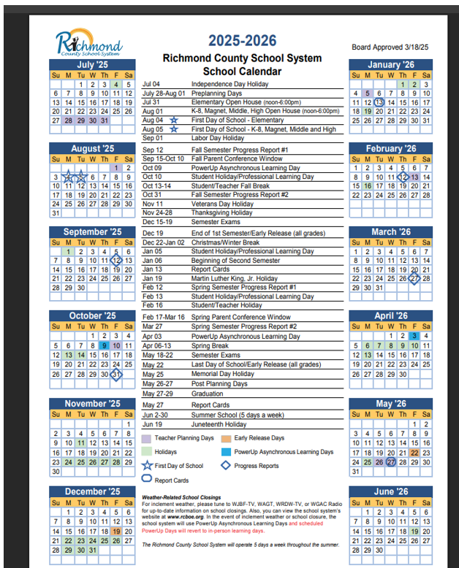

**HOURS OF OPERATION**

**School Office Hours**

The front office is open Monday-Friday, 7:45 am-3:45 pm.

**Instructional Day**

The instructional day for students is from 8:20 am - 3:10 pm.

**Students are not to enter the building nor be left at** **school** **unattended** **before** **7:50** **a.m.** **or** **after** **3:30** **p.m.** **School** **personnel** **cannot** **assume** **any** **responsibility** **for** **their** **safety.** **Parents** **who** **leave** **students** **unattended** **before** **and** **after** **designated** **hours** **are** **subject** **to** **referral** **to** **the** **school** **social** **worker** **and/or** **the** **Department** **of** **Family** **and** **Children’s** **Services.**

**Teacher Work Day**

Teachers work from 7:45 am-3:45 pm. However, all meetings and professional learning may begin as early as 3:30 p.m., or immediately after students are dismissed at 3:10 p.m.

**ARRIVAL & DISMISSAL**

Students may enter the building at 7:50 am for breakfast. Bus riders will enter the school building using the cafeteria entrance, and car and daycare van riders will use the car rider line entrance on Tubman Home Road. **Please do not drop students off at the front entrance. Staff members are on duty in the car rider area from 7:50-8:20 to assist students as they exit their cars and enter the building. Students are tardy at 8:21 a.m. Any students arriving after 8:21 a.m. must be signed in by a parent. All students are expected to be out of the building by 3:30 p.m. Faculty meetings and teacher planning begin as early as 3:30 pm. PARENTS, PLEASE FOLLOW THE DIRECTIONS OF THE STAFF DURING STUDENT DROP-OFF AND PICK-UP TO AVOID ISSUES AND DELAYS WITH ARRIVAL AND DISMISSAL. ALSO, PLEASE DO NOT STOP/DROP OFF IN A MANNER THAT WILL BLOCK MORNING OR AFTERNOON TRAFFIC FLOW**. Parents are not permitted to park, drop off, or pick up students in the bus loading area. This is unsafe and interferes with bus arrival and dismissal.

**COMMUNICATION/CLASS DOJO**

Wilkinson Gardens uses Class Dojo to maintain ongoing communication with parents and students. Please accept the invitation to join your child’s class. Class Dojo will allow you to receive information and communicate consistently with teachers.

**TRANSPORTATION**

Please refrain from calling the school office to make transportation arrangements. **Transportation changes must be provided to the school office in written form.** **Written, signed notes may be sent with the student, faxed, or emailed before 2:45 p.m.** If a written, signed note is not received and no emergency change has been approved, the student will go home the regularly scheduled way.Telephone calls will not be accepted except in case of extreme emergencies after 2:45 pm in order to prepare for dismissal. **In case of an emergency, parents/guardians must speak with an administrator.** Our students are young and may get confused with multiple forms of transportation. Please try to maintain a set method of transportation. Students may ***not*** be removed from buses after they are loaded or have left the school.

### Bicycles

Students will be allowed to ride bicycles to school if the following rules are followed: •

* Bike riders must wear helmets. This is a state law;
* Bike riders must dismount and walk bikes upon entering school property;
* Bicycles must be stored in the bike rack. Locks are not required, but they are strongly recommended; as the school is NOT responsible for stolen or damaged bicycles.

Parents/guardians should discuss traffic safety precautions and routes to school with their child(ren) BEFORE students ride their bikes to school. Please visit the Georgia Safe Routes to School website for more information on bicycle and pedestrian safety.

**Car Rider & Bus Rider Tags**

Parents/guardians who pick their child up from school in the afternoons should follow the direction of staff for a smooth and safe dismissal. If car rider Car Rider tags are provided, please displayed in the front windshield on the passenger side of the vehicle. **All students in grade K-3 will receive a bus tag to attach to their book bags for the first 2 weeks of school.** The tags will include the child’s name, bus number and parent contact information. **Please be sure students LEAVE THE TAGS ATTACHED TO THEIR BOOK BAGS,** in an effort to better ensure students leave school provided the proper form of transportation and **GET HOME SAFELY**.

### School Bus Regulations/Rules

Riding the school bus is a privilege. Students are under the supervision of bus drivers and should heed their direction(s). Improper conduct on the bus or at the bus stop can result in that privilege being revoked.

Reported acts of misconduct on the bus may be investigated. Copies of the bus rules are available as needed.

Fighting: Typical procedures are as follows:

**1st Report:**  Verbal Warning / Letter sent home to be signed and returned.

**2nd Report:** Writte**n** Warning Letter and Call by an Administrator to Parents.

Conference may be required before child can return to bus.

**3rd Report:** 3 Days SUSPENSION from bus

**4th Report:** 5-10 Days SUSPENSION from bus

**5th Report:**  Conference required with bus driver and administrator to determine future bus

privileges. Parent attendance is necessary.

**6th offense:** Expulsion from bus for the remainder of the school year

**\*\*\*If the administrator determines that an offense is serious enough, ex: fighting on the bus, etc., suspension may result immediately and possibly indefinitely. \*\*\***

## **ATTENDANCE LAW & POLICIES**

### Georgia Compulsory Attendance Law

Any parent, guardian, or other person residing in Georgia who has control or charge of a child or children between the ages of 6 and 16 years of age, and any child residing in Georgia and Richmond County between the ages of 6 and 16 years of age, is required under Georgia law to enroll and attend school. Under the provisions of Georgia’s Compulsory Attendance Act, each day’s absence from school after a student has accumulated five (5) days of unexcused absence, whether consecutive or not, can constitute a violation of the law and can subject the parent and student to penalties which may include a fine of not less than Twenty-Five Dollars ($25.00) and not greater than One Hundred Dollars ($100.00), imprisonment not to exceed thirty (30) days, community service, court supervisor as a juvenile offender, or any combination of these penalties***.*** For detailed information regarding attendance, please refer to the ***RCSS*** ***Code*** ***of*** ***Student*** ***Conduct*** ***and*** ***Discipline***.

**Absences**

Regular, punctual attendance is extremely important for school success. Students are expected to be present at school. Students checking out before 12:30 p.m. or arriving after 12:30 p.m. will be considered absent. A student’s yearly attendance is recorded as part of his/her permanent school record. In the event of an absence, a note from a parent/guardian explaining the reason for the absence is required for each absence in order to possibly excuse the absence. This note, signed by the parent, should be submitted to the homeroom teacher upon the student’s return to school. The student is responsible for all make-up assignments within five (5) days if credit is desired. In cases of unexcused absences, the student may not be given make-up work. The only excusable absences are those prescribed by state statutes, rules, and regulations of the Department of Education and local board policy. Guidelines for lawful excuses and extended absences are listed in the Richmond County Student Code of Conduct and Discipline. Also, please reference the RCSS Attendance Protocol below.

### Tardies

Students who arrive at school after 8:21 a.m. will be counted as tardy. Tardy students must report to the office to check in and receive a Tardy Slip in order to be admitted to class. **Parents/guardians** **must** **accompany** **students** **when** **they** **are** **tardy** **and** **parents/guardians** **must** **sign** **in** **their** **child(ren)**. Students whom are tardy to school will be disciplined according to the guidelines in the Student Code of Conduct and Discipline. Teachers are not required to allow makeup work for unexcused absences or frequent tardies.

**Special Notes: Tardies and/or Early Dismissals on 10 or more days will disqualify a student for**

**yearly Perfect Attendance awards, as 10 tardies = 1 absence.**

**EARLY DISMISSAL PROCEDURES/EARLY RELEASE**

On the rare occasion when a child needs to be signed out before the regularly scheduled dismissal time, parents/guardians must come into the Office, sign the student out on the computer at the front desk, and an office worker will call the child to the office for dismissal. Students will **not** be called to the office ahead of time so they can “be ready” when the parent/guardian arrives. Students will **not** be sent out to vehicles. Early dismissals count as tardies as part of the attendance protocol. Students will not be released after 2:45pm daily (teachers and students are preparing to get in place for dismissal), nor released to anyone other than the parent or guardian or other authorized person(s) noted on registration paperwork and/or as noted in Infinite campus per parent/guardian written notice/documents. Parents or guardians must send documentation to school for absences to be excused. Your child’s academic success may be jeopardized if he/she is consistently signed out before 3:10 pm. **On** **Early** R**elease** **days,** **Wilkinson Gardens will** **release** **students** **at** **12:45 pm.** **See the 2025-2026** **school** **calendar** **for** **dates.**

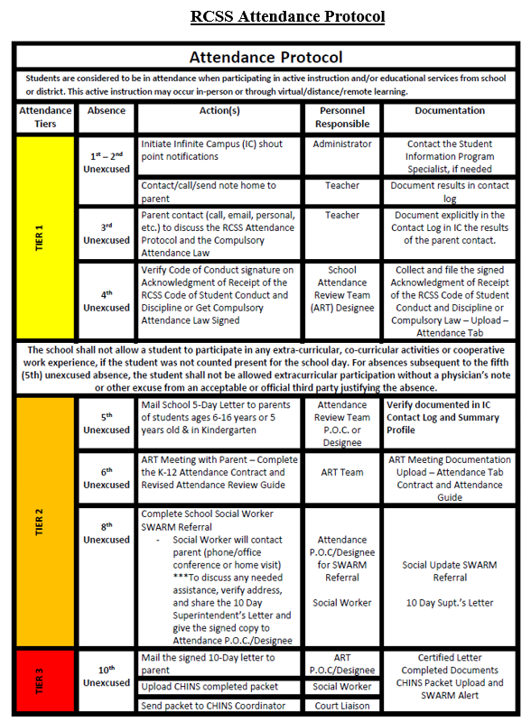

**PARENTAL INVOLVEMENT**

This Code of Conduct is based on the expectation that parents, guardians, teachers and school administrators will work together to improve and enhance student behavior and academic performance and will communicate freely their concerns about, and actions in response to, student behavior that detracts from the learning environment. School administrators recognize that two-way communication through personal contacts is extremely valuable; therefore, they provide information to parents as well as ongoing opportunities for school personnel to hear parents’ concerns and comments.

The Code of Conduct specifies within its standards of behavior various violations of the Code, which may result in a school staff member’s request that a parent or guardian come to the school for a conference. Parents are encouraged to visit the schools regularly, adhere to the policy below, and are expected to be actively involved in the behavior support processes designed to promote positive choices and behavior.

Georgia law also provides that, under certain circumstances, a teacher has the authority to remove a student whose behavior is in violation of the student code of conduct from his or her classroom if the student repeatedly or substantially interferes with the teacher’s ability to communicate effectively with the students in the class, with the ability of the student’s classmates to learn, or if the student poses an immediate threat to the student’s classmates or the teacher. The procedure is detailed in local policy and state law**.**

Georgia law mandates that any time a teacher or principal identifies a student as a chronic disciplinary problem student, the principal shall notify by telephone call and by mail the student’s parent or guardian of the disciplinary problem, invite the parent or guardian to observe the student in a classroom situation, and request at least one parent or guardian to attend a conference to devise a disciplinary and behavioral correction plan before the student return to school from suspension).

The law allows a local board of education to petition the juvenile court to require a parent to attend a school conference. If the court finds that the parent or guardian has willfully and unreasonably failed to attend a conference requested by the principal pursuant to the laws cited above, the court may order the parent or guardian to attend such a conference, order the parent or guardian to participate in such programs or such treatment as the court deems appropriate to improve the behavior, or both. After notice and opportunity for hearing, the court may impose a fine, not to exceed $500.00, on a parent or guardian who willfully disobeys an order of the court under this law.

**Volunteers & Visitors**

Volunteers are an invaluable asset in helping to meet the needs of students and staff. However, it is imperative that faculty and staff know who is present in the building and possibly around students at all times, and that we always maximize and not interfere with instructional time. **All** volunteers and visitors **must** report to the Front Office upon entering the building. Visitors will be allowed to conduct business or visit classrooms as authorized by the Policy below. While we welcome visitors, the regular school program must continue, so please do NOT place demands on teachers for conferences, etc. **during instructional time**. In addition, we request that younger siblings/children are not taken to the classrooms when volunteering because of the interference with teaching and learning.

By action of the 2012 Georgia General Assembly, all school volunteers in Georgia are now "mandated reporters" of suspected child abuse. [O.C.G.A. Section 19-7-5]. Therefore, if by direct observation, a verbal/written communication, or by some other means you become aware or form a reasonable suspicion that a child has been abused either at school or at home, you must report this information to the principal. Once you have reported your knowledge, it then becomes the responsibility of the administrator to report the suspected child abuse to the appropriate state or local investigative agency.

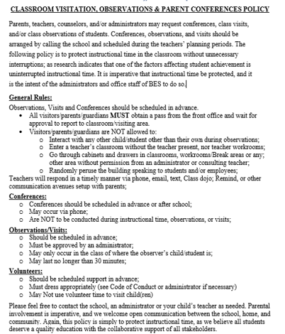

**DRESS CODE POLICY**

Students are expected to follow the dress code outlined in the Richmond County Student Code of Conduct and Discipline while attending school, school-related functions, and to maintain a type of appearance that is not distracting to teachers or students. Clothing items should be clean, neat, and modest. “Fashionable” wear is not always appropriate school attire.

**The following are *NOT* acceptable**:

* Clothing or accessories advertising alcoholic beverages, drugs, tobacco, or weapons;
* Clothing, hats, hairstyles, or accessories containing inappropriate language, messages

or designs;

* Sun dresses, tank tops, tube tops, halter tops, see-through shirts, fishnet or mesh material shirts, crop-tops, one-shoulder or off-the-shoulder blouses, and blouses with open backs;
* Shirts, tops, blouses, or sweaters that show cleavage;
* Bare midriffs – all shirts, blouses, etc., must cover the top of pants, slacks, shorts, etc., whether standing or sitting;
* Pants, shorts, skirts, etc. with writing on the buttock area, as well as lace-up legs;
* Any clothing item that is too tight or loose;
* Any clothing item that is too short (shorts, skirts, and dresses must be as long as the length of the middle finger when hands are down by the student’s side, AND at least mid-thigh);
* Any clothing item that shows a student’s undergarments;
* Baggy or sagging pants;
* Heeled and/or high platform shoes (unsafe and inappropriate on normal school days/events);
* Combs, picks, hairnets, scarves, bandanas, headbands, hair rollers, etc.;
* Bandanas (colored or white) at any time or on any part of the body;
* Hats, caps, stocking caps, dew rags, etc., except on special designated “Hat Days”;
* Sunglasses or shades inside the building;
* Visible body piercings other than earrings;
* Extremely colored/dyed hair that causes a disruption to the instructional process in the class.

**\*\*\*The principal or other duty authorized school official shall determine whether any particular mode of dress or apparel results in the disruption of the normal day.\*\*\***

**GROOMING STANDARDS**

WGE consistently enforces the school grooming standards for ALL individuals who enter the building. We ask that ALL visitors/parents entering the building meet or exceed the following grooming standards: **The following *are* acceptable and expected:**

* Appropriate attire (**NO** pajamas, see-through or sheer clothing, or short shorts/skirts)



* Outer clothes must completely cover underclothes and garments
* Shoes and Shirts must be worn in the building; Tennis shoes should be worn when participating in the school’s physical education program, and laces tied at all times.
* Pants with holes or cut-outs are permissible **only** if they are lower than mid-thigh.
* Tights and leggings are ***only*** worn under skirts or dresses at the appropriate length.
* All pants, jeans, shorts, etc. must be fastened at the waist at all times and are to be worn at the appropriate waist level.

*The* *school* *administration* *reserves* *the* *right* *to* *delete* *or* *add* *to* *Student* *Dress* *Code* guidelines *as* *the* *need* *arises* *to* *address* *the* *ever-changing* *issues* *related* *to* *changing* *fashions. Should* *a* *question* *arise* *concerning* *the* *appropriateness* *of* *a* *student’s* *dress,* *the* *school* *administration* *reserves* *the* *right* *to* *determine* *what* *they* *deem* *as* *appropriate* *and* *what* *is* *NOT* *in* *regards* *to* *the* *disruptive* *nature* *of* *the* *clothing,* *dress,* *adornment,* *etc.,* *to* *the* *educational* *process.*

**\*\*\*Continuous violations of these regulations will result in disciplinary action.**

## **Discipline & Conduct**

At Wilkinson Gardens Elementary, we believe it is the shared responsibility of the home and the school to instill and help students maintain discipline and good conduct. ***Discipline*** is the key to good conduct and proper consideration for other people. Good discipline is maintained by recognizing and praising good behavior and taking corrective action when necessary.

Students at Wilkinson Gardens Elementary School are expected to put forth their best effort and to act appropriately at all times in a manner that will promote a safe, orderly learning environment. A behavior R.O.A.R. chart is posted throughout the school as a reminder of good behavior. Teachers will spend a good bit of time at the beginning of the year discussing behavior and expectations. The school Counselor also provides lessons on character education to remind students of appropriate behavior. Any behavior that causes a disruption in the learning environment and infringes upon the rights of others in the school will not be tolerated. Thus, misbehavior is subject to consequences.

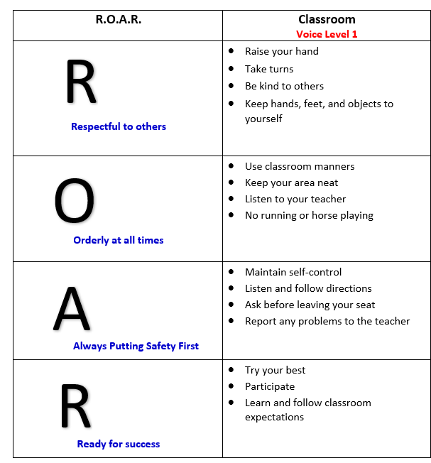

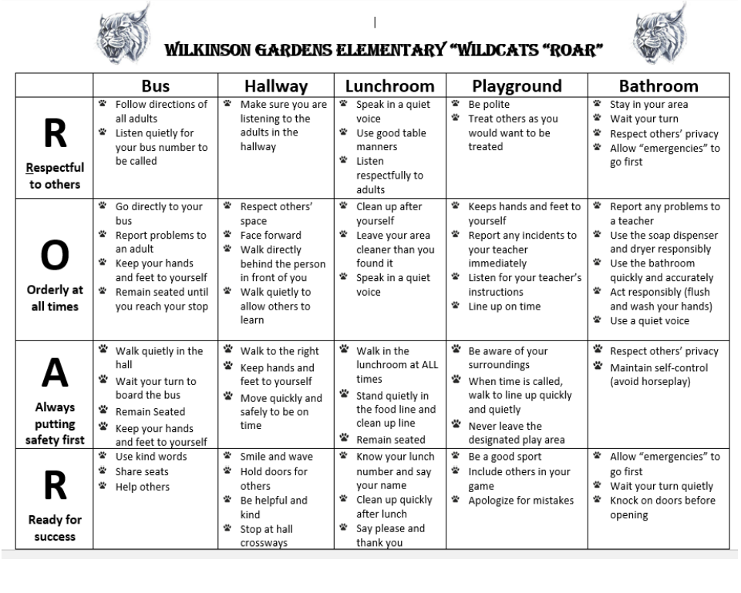

### Conduct Rules

Good student conduct sets the tone for other positive things to happen in school. As a result, a positive school climate plan, via the R.O.A.R. Behavior Chart, has been developed and will be implemented. In addition, WGE has adopted a PBIS approach (Positive Behavioral Interventions and Supports) to encourage acceptable behavior. Parents are an integral part of the plan and may be directly involved with its on-going implementation. The students themselves play an important role in their own educational programming. The class is neither teacher dominated nor student-controlled; rather, it is a joint effort to learn, relate, and experience. Celebrations are held throughout the year to encourage students to exhibit and maintain positive behavior. The following are general rules of conduct for all students at Wilkinson Gardens Elementary School at all times:

1. Disturbances that disrupt the learning opportunities for others in class are prohibited.
2. Students are expected to obey reasonable directives of all school personnel.
3. Rude, discourteous, disobedient, or defiant behavior is prohibited.
4. Profanity, obscenities, and/or insulting remarks will not be tolerated in school or on school grounds.
5. Threatening and/or intimidating another student or adult is prohibited, including such statements as “I’m going to kill you.”
6. Hitting, rough housing, fighting, and physical abuse with the intent to hurt another student or adult is prohibited.
7. Assault and/or battery on a school employee or another student is prohibited.
8. No student shall leave campus without permission from an authorized adult.
9. Failure to tell the truth, forging or knowingly using a forged signature, stealing, cheating, and plagiarism (giving or receiving information) are prohibited.
10. Falsifying, misrepresenting, omitting, or erroneously reporting information regarding instances of alleged inappropriate behavior by a teacher, administrator, or other school employee toward a student.
11. The willful damage or destruction of property is prohibited.
12. Tampering with fire safety equipment and/or setting off a false alarm is prohibited.
13. Bullying in any form is prohibited.

**Richmond County Schools Code of Conduct**

It is the purpose of the Richmond County School District to operate in a manner that will provide for the welfare and safety of all students who attend the schools within the district. In accordance with that purpose, the Board of Education has adopted a policy which requires all schools to adopt codes of conduct that require students to conduct themselves at all times in order to facilitate a learning environment for themselves and other students. These standards for behavior require students to respect each other, school district employees, to obey student behavior policies and rules adopted by the Board and established at each school within the district. The school’s primary goal is to educate, not punish; however, when the behavior of an individual student comes into conflict with the rights of others, consequences may occur for the benefit of all individuals and the school as a whole. Accordingly, students shall be governed by the policies, regulations, and rules outlined in this Code of Conduct.

The Code of Conduct is effective during the following times and in the following places:

* during school hours;
* at school or on school property at any time (in session or not);
* off school grounds at any school function or event (to include travel to and from)
* on vehicles provided for student transportation by the school system and bus stops

Students may also be disciplined for conduct off campus, which could result in criminal charges with a felony, and which makes the student’s continued presence at school a potential danger to persons or property at the school, or which disrupts the educational process.

Parents are encouraged to review the Code of Conduct with their child/children and to be supportive of it in their daily communication with their child/children and others in the community. Consistent with Georgia law and the mandate of the Georgia General Assembly, all parents/guardians are encouraged to inform their children of the consequences. For detailed information regarding the ***RCSS*** ***Code*** ***of*** ***Student*** ***Conduct*** ***and*** ***Discipline***.

### Progressive Discipline Procedures

When it is necessary to impose discipline, school administrators and teachers will follow a progressive discipline process. The degree of discipline to be imposed by each school official will be in proportion to the severity of the behavior, with discipline history and age taken into consideration.

The Code of Conduct provides a systematic process of behavioral correction in which inappropriate behaviors are followed by consequences. Disciplinary actions are designed to teach students self-discipline and to help them substitute inappropriate behaviors with those that are consistent with the character traits from Georgia’s Character Education Program.

**GENERAL SCHOOL RULES**

**Assembly Rules**

1. Enter and leave quietly.
2. Sit in your assigned area.
3. Be courteous during the program and listen while the speaker speaks.
4. Show appreciation at the appropriate time (applause as necessary).

**Classroom Rules (These are general rules. Classroom rules may vary by teacher.)**

1. Listen to and follow all directions given by the teacher.
2. Do not disrupt or interfere with students’ ability to learn, nor the instructional delivery.
3. Be prepared with the necessary materials and assignments.

**Hall Rules**

1. Walk. No running.
2. Stay in line and remain on the right side of the hall.
3. Be quiet and courteous.
4. Stop at the restroom or water fountain only with permission.
5. Always have a hall pass.

**Lunchroom Rules**

1. Walk always and use quiet voices in line and at tables.
2. Do not play with food.
3. Clean your personal space before you leave. 4. Place trays in the window one at a time.
4. All food must remain in the cafeteria.
5. All students are required to get a tray or bring a lunch from home.
6. Students are not allowed to bring fast food items in their original containers.
7. Students should not bring non-nutritional food items, such as cookies, candy, chips, or drinks in place of lunch. These items included in a lunch from home are acceptable.
8. Student lunches cannot be warmed at school.

**Playground Rules**

1. Use equipment properly and safely.
2. Take turns.
3. Do not throw rocks or any other objects or toys.
4. Put all trash in trash cans.
5. No running on sidewalks.
6. Play in your designated area.

**Restroom Rules**

1. Wash your hands before leaving.
2. Have a hall pass unless accompanied by an adult.
3. Use facilities properly (quietly and safely).
4. Flush urinals and toilets after each use.
5. Do not place foreign objects or excess paper in sinks, toilets, or urinals.
6. Do not play in the water.

### Student Support Team

The Richmond County Board of Education provides a variety of resources that are available at every school within the district to help address student behavior problems. The school discipline process will include appropriate consideration of support processes to help students resolve such problems. These resources will include Response to Intervention Teams, school counselors, school social worker, behavior analysts, and chronic disciplinary problem student plans.

### Authority of the Principal

The principal is the designated leader of the school and is responsible for the orderly operation of the school. In cases of disruptive, disorderly or dangerous conduct not covered in this Code, the principal may undertake disciplinary measures believed to be in the best interest of all students provided any such action does not violate school board policy or procedures.

**RESPONSIBILITY FOR PROPERTY**

Students are personally responsible for textbooks, library books, instructional materials, and desks assigned to them. Students must pay for any damages. Assessment of damage will be determined by the school administration. However, elementary school students who fail or refuse to pay for lost or damaged textbooks, library books, or media materials at the replacement cost shall be refused additional textbooks, library books, or media materials and will have their report cards, diplomas, certificates, etc. held until the restitution has been paid in full. **School Property**: Parents will be billed and held liable for property that is damaged by students during the school year. A bill will be calculated by the Maintenance Department and provided by the school, payment is expected upon receipt.

**LOST AND FOUND**

Items that have been found at school should be placed in the Lost & Found boxes located in the gym. Lost articles can be claimed by properly identifying the lost item. We recommend that parents label all personal items with the student’s name, so they can be quickly identified and returned to the owner without delay.

**FIELD TRIPS**

During the school year, parents may be asked to give permission for their child to go on a class field trip. A form will be sent home for the legal guardian's signature before a student will be permitted to go on a field trip. Any student who has not returned the signed permission form to participate will remain at school under the supervision of another classroom teacher. NO siblings are allowed to attend the school-sponsored activity of their brother or sister. Parents who wish to chaperone a trip must have a current volunteer card/status on file (see Volunteer Policy). For voluntary out-of-town field trips that utilize a bus service, complete support of parents will be required. When a trip of this nature is planned, the cost will be the same for all students regardless of the mode of transportation used. If a parent opts to drive instead of riding the bus, the cost will be the same. Also, if a parent drives, other siblings are not allowed to attend the school-sponsored trip. Remember, all field trips are classroom activities and are not intended to be family trips or fun days.

**FIRE DRILLS**

Fire drills will be once a month at regular intervals. They are required by law and are an important safety precaution. It is essential that when the first signal is given, everyone obeys orders promptly and clears the building by the designated route as quickly as possible. The teacher in the classroom will give the students instructions as to their exit route and line up area. Fire drills are essential and should not be taken lightly.

**GIFTED PROGRAM**

Richmond County provides programs for all qualifying system students in grades K-12 who exhibit superior performance, advanced learning needs and demonstrate higher-level motivation and creativity. The identification process uses multiple criteria as mandated by the Georgia Board of Education and the Richmond County School System Gifted Policy. All students placed in the Richmond County Gifted Program must meet the mandated Georgia Department of Education eligibility requirements. Referrals are solicited from all system schools twice annually for testing students. Students may be referred by parents, peers, school personnel, and self. Students entering the system who had prior placement in a gifted program will be placed at once if they meet Georgia Department of Education eligibility. Gifted Program staff will evaluate those who do not have the required eligibility documents. Students are enrolled in a resource program and are served five hours per week. Mini-units integrating the academic areas form the basis of the curriculum. Units for each grade level include the basic skills areas basic to gifted education:

• Developing cognitive skills

• Communication skills

• Creative thinking skills

• Metacognition and learning skills

• Research and Reference Skills

**SMOKE-FREE ENVIRONMENT**

Staff and all visitors are prohibited from smoking or using tobacco or smokeless tobacco products to include e-cigarettes, while on school board property during the regular school day or while attending any school-sponsored function.

**SOCIAL SECURITY NUMBERS**

Social Security numbers are requested to be used for identification purposes. The child's social security card should be presented at registration. A copy will be made and the card returned. Every safeguard will be used to protect and secure this information.

**SCHOOL PARTIES:**

* Pre-K – 5th grades may have parties to celebrate Christmas and the end of the year.
* Student birthday Parties should not be celebrated at school. However, during lunch, with teachers present, students may share cupcakes or a birthday treat with their classmates.
* Balloons (with helium) are NOT allowed in the school building.
* Birthday party invitations will NOT be distributed at school unless everyone in the class is receiving an invitation.

**FUNDRAISING**

During the course of the school year, students will have opportunities to participate in fundraising activities. These activities are sponsored by the school and PTA, and other school clubs/groups/teams. Participation is optional. We do not encourage students to sell items door-to-door.

**TITLE I PROGRAM**

Title I is a federally funded program designed to provide additional educational services in designated schools to students in core curriculum. There are two types of Title I programs: Targeted Assistance and School-wide. WGE has carefully developed an instructional plan to provide a research-based, well-sequenced, and timely improvement program. Parents are encouraged to become involved in parent activities held throughout the year. Questions regarding Title I program services may be directed to the Principal, Assistant Principal or to the Program Director at the RCSS Board Office 706-860-1000.

**SPECIAL EVENTS**

There will be several opportunities during the school year in which we solicit your participation and cooperation. These include but are not limited to: Open House, Honors Day, Field Day, Science Fair, Spelling Bee, Book Fair, Skate Night, and other parent engagement activities.

**SPECIAL PROGRAMS**

Special education programs are provided for students who qualify in the areas of speech/language, emotionally/behaviorally, learning disabled, or gifted.

**STUDENT DELIVERIES**

Students may not receive flowers, balloons, presents, or other deliveries of this nature at school. Parents are requested to celebrate special occasions and holidays at home.

**VISITORS**

Upon entering the school during the day, all visitors are required to go directly to the office. Other than students, faculty, and staff members, no other person is permitted in the school building without the permission of the Principal or her designee. Please observe this necessary rule and refrain from going directly to your child’s classroom. All visitors to our school must check in at the office upon arrival at the school. Please do not stop to visit with the teacher, class, other students, or staff members without receiving authorization at the office. This includes all school areas, both in and out of the building and refers to all parents and visitors. Your cooperation in this matter will help us ensure the safety of the children and cause fewer disruptions of school routine. Visitors are not allowed to question other students or staff members concerning events that happened at the school. Students come to school to learn and should not be forced to mediate for other children. Parents are asked to drop their children at the front door and not walk their children to class after the third week. If you decide to come to school at the close of the day to pick up your child, please do not go to the child’s classroom. To eliminate disruptions, we prefer that you wait in front of the school until school is dismissed. Thank you very much for your cooperation and understanding.

**VOLUNTEERS**

Volunteers are needed. A volunteer is one that comes to the school to assist as classroom helpers. If you would like to read stories, create art, work with the classroom, office, library, lunchroom, clinic, or any other area, we solicit you to come out and will be most appreciative of your help. Your expertise, service, and time are important. Those who are able to help are asked to contact the school office. All volunteers in the school are required to attend a training workshop provided by the county or at school. Adults without a current approved volunteer status cannot attend or supervise school field trips or class activities.

**CELL PHONES, PAGERS & OTHER ELECTRONIC DEVICES**

A new cell phone policy has been adopted by the Richmond County School System. The policy will be followed, and consequences will be enforced. Cell phone use is not permitted on campus at Wilkinson Gardens Elementary School. If a student has been instructed to carry a cell phone by a parent/guardian, it should remain off and in the student’s bookbag during school hours and on campus. A student will be subject to disciplinary action per the cell phone policy and Code of Conduct, including, but not limited to, in-school suspension, out-of-school suspension, or expulsion, if the student utilizes a pager, cell phone, or other electronic device to engage in inappropriate use of technology. The following are some examples of inappropriate use of technology:

* bullying, threats or intimidation, or harassment of any form, to create and/or send and/or receive and/or possess and/or transmit to others pornographic or obscene pictures or messages to create and/or send and/or receive and/or possess and/or transmit to others offensive or humiliating or inappropriate pictures of one’s self or others,
* Engaging in academic cheating in any form
* Invading anyone’s privacy in a locker room, restroom, or other place on a school campus or at a school activity

It is imperative that we consider the safety of all students and minimize issues with cell phones during school hours. If a student must have a cell phone or electronic device, it should **be in the student’s bookbag and powered off during the instructional day**. If a student uses a cell phone or other electronic device of this nature at school, during the instructional day, or in a manner that is disrespectful or disruptive while on campus, on the bus, the device will be taken from him/her, and turned in to the office with a note containing the student’s name, date, time and teacher’s name. The device will be held in the Principal’s Office until a parent has been contacted and comes to the school to retrieve the device. Second offenses will result in the device being kept for 30 days, or as stated in the new RCBOE policy/code of conduct. Upon the third offense, additional disciplinary consequences will apply, and the device will be kept for the remainder of the semester or school year (or as stated in the new policy/Code of Conduct). **Parents, please be assured that all teachers have access to a class phone, an emergency badge to alert administration and the authorities in the event of emergencies. Each grade level has access to a radio, each teacher’s lounge has a phone, and there are several phones in the front office.** Please refer to the ***RCSS*** ***BYOT Policy/Cell Phone Policy/Code of Conduct*** for more information on technology use on RCSS school property.

**GRADING POLICY**

Students in Grades K-5 are required to perform academically as well as on grade level in all content area classes. Effective July 1, 2022, the new IHA-R Grading Policy will be in effect. There will be 2 grading periods annually, grading period 1- first semester, and grading period 2- second semester. Students will receive two progress reports and 1 report card during each semester of school, for a total of 4 progress reports and 2 report cards annually. Please be sure to set up your parent portal account before or during Registration/Open House and monitor grades regularly.

### Standards-Based Report Card for Grades K-3

The purpose of the new reporting system is to provide parents, teachers, and students with more accurate information about students' progress toward mastering standards. On a standards-based report card, each of the subject areas is divided into a list of standards/learning targets/skills and knowledge indicators that students are learning. This provides a concrete understanding of exactly what students know. Progress is measured as follows:

**Report cards for grades K-3 will include an academic performance level of 1-4 or P.**

1. **– Beginning Learner/Not Met:** Knowledge of the standard has not been demonstrated.
2. **– Developing Learner/Meets:** Some knowledge of the standard has been demonstrated.
3. **– Proficient Learner/Meets:** Adequateknowledge of the standard has been demonstrated.
4. **– Distinguished Learner/Exceed:** knowledge beyond the standard has been demonstrated.

**P- Pass**: The student has passed this class. (example: Art, Music, etc).

If an indicator is not measured during the grading period, the student will NOT receive a mark on the report card.

**Traditional Report Cards & Grading System for Grades 4 – 5**

A = 90-100 B = 80-89 C = 75-79 D = 70-74 F = Below 70

### Progress Reports, Report Cards, and Grade Reports

Progress reports and report cards will be issued throughout the school year. Refer to the

Academic calendar for release dates. A parent/guardian’s signature is required before report card jackets are returned to the child’s homeroom teacher.

Graded assignments may be sent home weekly. Parents/guardians are asked to examine, sign, and return the papers to the child’s teacher(s) the following day. Parents should contact the child’s teacher or the School Office immediately if questions or concerns arise.

**HOMEWORK**

Teachers may assign homework daily. In the event your child doesn’t have homework, he/she should read at least 30 minutes, practice sight and/or vocabulary words, strengthen basic math fluency (addition, subtraction, and multiplication facts), and/or review material from the day’s lessons.

The purpose of homework is to provide an opportunity for students to practice what has been taught, reinforce learning, instill a sense of responsibility, involve parents in the learning process, which also helps parents see where their child’s level of understanding is, and it gives teachers the opportunity to provide useful feedback to students. Thus, it is very important for parents to work with students to complete the assigned homework (if given) and/or practice daily. Homework will not exceed the student's ability to complete in a reasonable amount of time.

**LATE WORK**

Late work is defined as assignments that are submitted after the specified deadline. This does not apply to work submitted late due to absence from school. Students are expected to submit assignments on time. Multiple incidents of late work may result in teacher-student-parent conferences to examine and correct the student’s work habits through an academic contract. Late work submitted after the fifth school day will only

be accepted at the teacher’s discretion. Completing work in a timely manner during the learning

unit is essential for academic success.

**MAKE-UP WORK**

Students are expected to make up assignments and assessments that were missed due to absence from

school. Students/Parents are responsible for asking teachers for the make-up work upon returning to class.

Make-up work should be completed by the student within the time specified by the teacher. Generally, such work should be completed within 5 days of returning to school. Graded assignments should be scored to accurately reflect the level of mastery of standards.

**PROMOTION, PLACEMENT AND RETENTION POLICY**

### Elementary

A student shall be promoted when, in the professional judgment of the teacher/s and the principal, and other professional school staff, he/she has successfully mastered the identified instructional standards of Georgia Public Schools (K-5) and Richmond County Board of Education.

**State Promotion Requirements**

* No third-grade student shall be promoted to the fourth grade who does not achieve grade level on the state-adopted assessment and meet the local promotion standards and criteria established by the Richmond County Board of Education.
* No fifth-grade student shall be promoted to the sixth grade who does not achieve grade level on the state-adopted assessment and meet the local promotion standards and criteria established by the Richmond County Board of Education.

### Additional Richmond County Promotion Requirements Kindergarten

To meet promotion requirements, a student must master essential standards for Language Arts and essential standards for Mathematics as identified on the Richmond County Board of Education report card.

**Grades First through Third**

To meet promotion requirements, a student must master essential standards for Language Arts, Math, Science, Health and Social Studies as identified on the Richmond County Board of Education report card.

### Grades Fourth and Fifth

In addition to State Promotion Requirements in grades third and fifth, students in grades first -fifth must:

1. Obtain a passing grade on the report card in Mathematics and Language Arts; and b) Obtain a passing grade on the report card in two of the following: Social Studies, Science and/or Health.

**COMMUNICATION FOR GRADES K-8**

If a student is not meeting the above requirements, the parent/guardian will be notified in the following manner:

1. Midway through the first nine weeks of school (4 1⁄2 weeks of instruction): A parent conference may be held to discuss strengths and weaknesses and offer suggestions for student improvement. A parent conference shall be scheduled to develop an educational plan for each student experiencing difficulties.
2. End of grading period 1 (18 weeks of instruction): At the end of grading period 1, the report card and the report card envelope will indicate with a check mark when the student is not making satisfactory progress toward promotion. The report card envelope will also indicate promotion difficulties. A parent conference shall be held for each student not making satisfactory progress toward promotion.
3. Midway through grading period 2 (27 weeks of instruction): At the end of grading period 2, the progress report will indicate with a check mark when the student is not making satisfactory progress toward promotion, and may indicate promotion difficulties. A parent may request a parent-teacher conference, to evaluate student progress in order to determine improvement needed to meet promotion requirements.
4. End of grading period 2 (36 weeks of instruction): A Conference must be scheduled for all students who are not meeting promotion requirements. The parent/guardian of a student who has been retained will be notified in the final report card.

***In addition to the communication described here, when a student does not perform at grade level in grades levels 3, 5, and 8 on the state adopted assessment (s) specified above the school system will also follow communication guidelines and procedures outlined by the Promotion, Placement and Retention State Rule 160-4-2.11 adopted November 6, 2014 and effective November 27, 2014.***

**ACADEMIC DISHONESTY**

Coursework submitted by a student must be the student’s own, original work. Students shall not cheat on any assignment by giving or receiving unauthorized assistance (parents completing assignments for students etc.), or commit the act of plagiarism (to include the unauthorized use of use of AI tools). Students who commit such acts are subject to receiving a grade of zero on the assignment in question as well as disciplinary action. Complete information regarding academic dishonesty can be found in the RCSS Code of Conduct and IHA-R Grading Policy.

## **STATE, STANDARDIZED and DISTRICT TESTING**

State mandates require student participation in a wide array of assessments. The purpose of the testing program includes monitoring student progress, assessing program effectiveness, planning for instructional improvement, and making placement decisions for special programming. Several of the assessments are utilized as part of the system’s promotion/retention policy. The following specific tests will be administered at BES:

**Kindergarten:** GKIDS, Literacy Task/ i-Ready Diagnostics and Progress Monitoring,

**Grade 1:** Literacy Task/ i-Ready Diagnostics and Progress Monitoring

**Grade 2:** Literacy Task/ i-Ready Diagnostics and Progress Monitoring, and CogAT

**Grade 3:** Literacy Task/ i-Ready Diagnostics and progress monitoring, GMAS

**Grade 4:** i-Ready Diagnostics and Progress Monitoring, GMAS

**Grade 5:** i-Ready Diagnostics and Progress Monitoring, and GMAS.

The state assessment program requires that students in kindergarten take GKIDS and students in Grades 3-5 will take the Georgia Milestones Assessment (GMAS). Individual test results will be provided to parents as soon as possible after the results are returned to the school. GA Milestones results will be used to guide and direct us in our instructional planning and a part of the Richmond County School System’s Promotion/Retention policy. Students in grades 1-5 will take local benchmark assessments. The CogAT assessments provide information about how students learn and think.

The school Principal or Assistant Principal(s) shall annually notify parents or guardians that placement or promotion of a student into a grade, class, or program will be based on the academic achievement of the student via several data sources to include GMAS, i-Ready, Grades, etc.

**Multi-Tiered System of Supports (MTSS) & Response to Intervention (RTI)**

The Multi-Tiered System of Supports (MTSS) is a regular education, problem-solving process at Wilkinson Gardens Elementary School (WGE). Student Support Team committees are established to review referrals of students who are experiencing academic and/or behavioral difficulties. The purpose is to provide support to students, parents, and teachers, with the outcome being improved student performance. SST committees may include an administrator, counselor, regular education teacher, special education teacher, school social worker, parent, school psychologist, and others, as appropriate for the case under review. The Student Support Team seeks to identify specific needs of individual students and plan alternative instructional strategies for children prior to or in lieu of referral for special services.

Response to Intervention (RTI) is the process of aligning appropriate assessment with purposeful instruction for all students. It is a tiered approach that provides layers of intervention for students needing support, requires a school-wide common understanding of the Common Core Georgia Performance Standards (CCGPS), assessment practices, and instructional pedagogy. WGE’s RTI process includes several key components:

* A 4-Tier delivery model designed to provide support matched to student needs through the implementation of standards-based classrooms.
* Evidence-based instruction is the core of classroom pedagogy.
* Evidence-based interventions are utilized with increasing levels of intensity based on progress monitoring.
* The use of a variety of ongoing assessment data to determine which students are not meeting success academically and/or behaviorally.

Students requiring interventions to meet individual learning expectations will receive support through a systematic and purposeful process.

**GUIDANCE AND COUNSELING DEPARTMENT**

Wilkinson Gardens Elementary School has a comprehensive developmental guidance and counseling program with many components. Our school counselor, Shea Beasley, is available as a support system to help students experience educational success. Individual counseling, small group counseling, and classroom guidance opportunities are services provided to improve student performance, self-awareness, and interpersonal skills. In addition, the school counselor provides information on careers, study skills, decision-making skills, and other life skills. Through collaboration with educators, parents, and community resources, our counselor assists with guiding students through their educational experience to ensure positive results.

**SCHOOL SOCIAL WORKER**

School social work services are offered to all Richmond County students and families. Requests for services may be made by referral. School social workers assist both parents and students with problems related to attendance, health, behavior, economic or social problems, and hospital/homebound activities. Social workers coordinate referrals to other community agencies when necessary.

**SCHOOL FOOD SERVICES**

All students will eat breakfast and lunch at no cost to parents/guardians at WGE. Breakfast will be served from 7:50 a.m. – 8:20 a.m. each morning for students in Grades PK-5. Lunch is served daily from 10:15 a.m. – 1:00 p.m. Classes are scheduled individually. Parents are welcome to eat with their child in the cafeteria as their schedule(s) allows. Commercially prepared foods should not be brought to the school by parents for a student’s meal. “Fast food” is **NOT** allowed in the Cafeteria. Beverages brought into the lunchroom must be in a plastic container or can. No glass containers! Students are expected to use good table manners at all times and to assist with keeping the lunchroom clean. Ice cream is available for purchase by students. Lunches will be prepared for ALL field trips.

**EMERGENCY DRILLS AND INCLEMENT WEATHER**

Fire drills will be held throughout the year. When the fire alarm is activated, students should quickly walk to the exit as directed by their teacher. Once outside the building, students should assemble in the area as directed by their teacher. Once the drill has been completed, teachers will be given a signal indicating when to return to the building.

Tornado drills will also be conducted. The administrative staff will provide instructions for this emergency procedure.

**INCLEMENT WEATHER**

Our district staff understands that our decision to open or close schools early in bad weather has a big effect on families during the inclement weather. We also understand that our students are better served – both academically and socially – by being in school. But as always, our top priority is the safety of our students. In the event that school is canceled due to other inclement weather, school closure announcements may be made in the following manner:

**HOW IS THE PUBLIC NOTIFIED?**

Tune to WJBF-TV, WAGT-TV, WRDW-TV news, WGAC-AM radio, or read the Augusta

Chronicle for up-to-date information on school closings. You may also view the school system’s website at www.rcboe.org.

**WHEN IS THE DECISION MADE?**

We will normally make the decision by 5:00 AM or earlier so we can notify radio and TV stations and post the decision on Richmond County School System’s website.

**MEDICAL CARE (SCHOOL CLINIC & NURSE)**

A certified nurse, Ms. Adrian Broadway, has been assigned to Wilkinson Gardens Elementary. The purpose of the clinic is to care for students who become ill or receive injuries at school.

1. A standard consent form must be completed on any medication, including non-prescription medicines, that will be dispensed at school. Written permission from parents will be accepted only on the first day of medicating; students will be required to return the completed consent form before any more medicine will be dispensed at school
2. No Tylenol or any other medications will be given at school unless it is sent from home with a standard consent form including instructions for dispensing the medication. The school cannot receive permission to give medicine over the telephone.
3. Medicines must be in the original container when brought to the clinic. Bring only the exact amount to be dispensed at school.
4. Medicines that have to be taken three (3) times a day should not be brought to school UNLESS specific times are prescribed. These medicines may be taken before school, after school and at bedtime.
5. A student with a temperature over 100 will not be allowed to stay at school. Please be sure that the office has an emergency contact number listed.
6. In case of illness during the school day, the student must report to the clinic and/or office BEFORE leaving the building. The school will contact parents so that arrangements can be made for the student to leave.

**ACCORDING TO GEORGIA STATE LAWS:**

1. Students attending a Richmond County school must prove that they have been immunized against seven childhood diseases (polio, mumps, measles, diphtheria, Whooping cough, rubella, and tetanus).
2. Any student entering a Georgia school for the first time or entering Kindergarten or First grade must have a dental, hearing, vision, and nutrition certificate.

The immunization Certificate and the Dental, Hearing, Vision, and Nutrition Certificate may be obtained at the Richmond County Health Department or from a private physician or a physician from Fort Gordon. Please note that any immunization record from another state must be transferred to the appropriate Georgia form. Please send the immunization record to the school nurse. According to existing laws and policies, students who do not have proof of the required immunization will be removed from school and the school roll until this record is submitted.

**HEALTH CONCERNS AND ISSUES:**

Parents should inform their child’s teacher of any health problems that the student has. These health problems include, but are not limited to, asthma, blood disorders, seizures, food allergies, substance allergies, medication allergies, reaction to bee stings, etc. If a child is on any daily medication for a certain

medical condition or has special medication for an emergency-type situation, the school, especially the child’s teacher(s), needs to be aware of these conditions and provided with the appropriate medication(s).

Covid-19, Chicken Pox, Mumps, Measles, Head Lice, Scabies, and Ringworm are just some of the extremely contagious diseases that appear at school from time to time. If your child contracts one of these contagious diseases, we would ask that the child remain out of school until he/she is free of the disease and fever before returning to school. If your child is found to have one of these diseases while at school or the child returns to school before the disease runs its course, you will be contacted and asked to pick up your child from school.

**Health and Immunization Records:**

State law requires that each student have proof of proper immunization of childhood and/or other diseases. All students must present a statement from the Health Department or a doctor, which indicates that all immunizations are up-to-date. Students whose immunization records are not current will be unable to enter school until this situation is rectified.

**Using Prescription Auto-Injectable Epinephrine:**

Like asthma medication, a student may carry or possess and self-administer a prescription auto-injectable epinephrine while in school, at a school-sponsored activity, while under the supervision of school personnel, or while in before-school or after-school care on school-operated property. Under Georgia law, however, a student is only permitted to do so if the student’s parents or guardians fulfill the following:

1. Provide the school with a written statement from a physician appropriately licensed under Georgia law detailing the name of the medication, method, amount, and time schedule by which the medication needs to be taken, and confirming that the student is able to self-administer the auto-injectable epinephrine; and
2. Provide the school with a written statement by the parent or guardian consenting to the self-administration, and
3. Providing a release for the school nurse or other designated school personnel to consult with the physician regarding any questions that may arise with regard to the medication, and releasing the school system and its employees and agents from civil liability if the self-administering student suffers an adverse reaction as a result of self-administering auto-injectable epinephrine. Notwithstanding the foregoing, a student may be subject to disciplinary action if he or she uses auto-injectable epinephrine other than as prescribed or violates any of the other provisions in this handbook that apply to the possession, use, transfer, or sale of prescription drugs with the auto-injectable epinephrine.

**Health Issues**

It may be difficult to decide early in the morning whether or not your child is sick enough to stay home from school. With minor symptoms, you often cannot tell whether he/she is going to get better or worse during the course of the day.

**The main reasons for keeping your child home are:**

• If he/she has a fever

• If he/she is too sick to be comfortable at school, and/or

• If he/she might spread a contagious disease to other children.

**As a rule of thumb, a child should stay home if there is:**

• A fever over 100.4° F;

• Vomiting more than once;

• Diarrhea;

• A very frequent cough;

• Persistent pain (ear, stomach, etc.); and/or

• A widespread rash.

If any of these symptoms occur during the school day, you will be notified and required to take your child home. If the parent cannot be contacted, the emergency number provided will be called. If no contact can be made, the student will be kept in class or in the nurse’s station until contact is made or until dismissal time. Home, work, and emergency telephone numbers should be kept up to date with the school office and the homeroom teacher. This is for the safety of your child!

Most of the above-listed problems need to be discussed with your child’s pediatrician to determine if an office visit is needed. On the other hand, children who don’t have a fever and only have a mild cough, runny nose, or other cold symptoms can usually be sent to school without harm to themselves or others.

**The following guidelines apply:**

* Minor cold or allergy symptoms should not be a reason to miss school.
* If your child’s cough is worse than you might expect with a common cold, you may need to consult your child’s doctor.
* A single episode of vomiting, without any other symptoms, may not be reason enough for the child to miss school, but be sure the school can reach you if symptoms continue that day.
* A single episode of watery diarrhea probably warrants not going to school.
* Children with a fever (generally over 100.4°) should stay home until there is no fever for 24 hours without the use of fever-reducing medications such as Tylenol or Motrin. Children diagnosed with strep throat or scarlet fever should remain out of school until they are without fever and have been on antibiotics for 24 hours. Children with pinkeye should see their doctor. If diagnosed, children should remain home until they have been on antibiotic eye drops at least 24 hours or until their doctor recommends their return.
* Middle ear infections are not contagious to others. Children with pain or a fever should stay home.
* Children who have been diagnosed with the flu should stay home until symptoms improve (usually 5 to 7 days) or until the doctor recommends returning.
* Impetigo is contagious and is passed by direct contact. The child’s physician will recommend the length of time to be out of school.
* Chickenpox is highly contagious. Children with chickenpox must stay home until all bumps are scabbed and no new bumps have appeared for 2 days. Your child is contagious at least 2 days before the rash started, so you need to notify the school and classmates.
* Ringworm is a contagious fungal infection. It may be treated with antifungal creams and should be covered during school hours.
* Scabies should be treated immediately.
* Head Lice: It is the policy of this administration that no child should have to endure or cause another child to endure public school nuisances such as head lice. Because this human parasitic insect can cause great annoyance to its host (children and adults), school medical personnel will routinely check students for infestation. If the school health professional determines that a student is infected, the student’s parents or guardians will be contacted and requested to come to the school for a conference, and to remove the child from school for treatment and remediation of the condition. A student will be checked upon returning to school. The child will not be allowed to return to school until he/she is nit and/or bug-free.

Whenever there is doubt about sending your child to school, consult your child’s doctor before doing so. A phone conversation may be all that is necessary. You may also call the Children’s

24-hour nurse advice line at 1-404-250-5437 for advice when your child’s doctor’s office is not open ***Remember to send a written excuse when your child is absent due to illness per the Attendance Policy.

**CONTACT & EMERGENCY INFORMATION**

It is critical for the school to know where parents work, how to reach them or who to call in the case of an emergency. Any change in the status of the aforementioned should be reported to the child’s teacher or the school office as soon as change occurs.

** At least one (1) emergency telephone number is REQUIRED for every student.**

**Infinite Campus**

Infinite Campus is the student information system used in Richmond County. Educators and parents have access. Parents can use the Parent Portal to view your child’s grades, attendance, and disciplinary actions. In order to gain access, you must be issued a number by the school Registrar. You may call the office and speak to the Registrar for assistance in setting up an account.

**Family Changes**

If the status of a student’s custody changes after the student is enrolled, the enrolling parent/guardian or agency shall notify the school of the new address and contact phone numbers. Parents/guardians may be required to facilitate and obtain appropriate guardianship or custody of their child to avoid referral to an outside agency or withdrawal. Accurate student information, to include a current address and phone number on every student, is imperative. In the event that you move, change employment, change phone numbers or contact people, please notify the office and your child’s teacher in writing immediately.

**Concerns and/or Questions**

Students/parents with concerns about a specific classroom situation should first confer with the teacher. Parents are encouraged to maintain contact with teachers to ensure maximum progress for their child. Parent-Teacher Conferences have been scheduled in the Fall and Spring. However, we welcome parents at any time that doesn’t conflict with instruction. If the issue is not resolved, the student/parent should make arrangements to see an administrator at WGE.

**DFCS/IRS Forms**

Parents/Legal Guardians requesting forms for DFCS or IRS will receive a copy of your child’s registration form. Parent/Legal Guardian must come to the school to pick up the copy.

**SAFETY**

A sincere effort has been put forth to make our school as safe as possible. Protective measures and procedures have been established with the safety of each child in mind. In order to enhance safety, everyone must abide by the following:

1. All exterior, classroom, and lobby doors are locked.
2. To enter the building, visitors must buzz the office and ask for admittance. From there, visitors may enter the Front Office to sign in and receive a Visitor’s Pass.
3. Students will not be released to persons who are not listed on the student’s information sheet. Persons picking up students will need to be prepared to show ID.
4. Tornado drills, fire drills, and other safety activities are conducted frequently to enhance safety.
5. Blocking the bus area, driveways, and fire lanes is restricted.

**GENERAL SUGGESTIONS TO PARENTS**

1. Please do not allow your child is not to bring dangerous or distracting articles to school, such as toy guns and knives, water guns, toys, radios, jewelry, etc.
2. Place names on all articles of outer clothing (coats, gloves, hats, sweaters, raincoats, etc.)
3. The school maintains a lost and found box. Please feel free to investigate if your child loses or misplaces something.
4. Instruct your child never to converse with a stranger, never to accept a gift from a stranger, and never to get into a car with a stranger.
5. Your child must have plenty of sleep (8 hours or more) each night for him/her to do good school work.
6. If there is something that you want to know about school, if something happened at school that worried you or your child, if there is a misunderstanding, or if you need more information for any reason, see your child’s principal.
7. Visit your child’s school. You, as a parent, are not only welcome at school, but you are urged to visit. It is highly desirable that you attend the various meetings.
8. You will also want to know your child’s teacher. If you wish to confer with a teacher, please call the school and make an appointment. You should not take his/her class time to discuss an individual problem.

**IDEAS FOR HELPING YOUR CHILD**

**Parents can do their part to improve homework when they:**

1. Cooperate with the school to make homework effective.
2. Provide your children with suitable study conditions (desk/table, lights, and supplies).
3. Reserve a time for homework. Turn off the television and cell phones. 4. Encourage your children, but avoid undue pressure.
4. Show interest in what your children are doing, but do not do the work for them. 6. Understand that the school expects homework to be completed and returned.

**Children will improve their study habits by observing the following:**

1. Study conditions should include good lighting, ventilation, and access to a quiet space.
2. Be sure you understand each assignment.
3. Form the habit of using a certain time and place for study.
4. Try to develop the skill of working independently.
5. Have the necessary materials at hand.
6. Prioritize and maximize time spent on each subject, as needed.

**EFFECT OF STUDENT HANDBOOK**

The policies, rules, and regulations shown in the Wilkinson Gardens Elementary School Handbook are regulatory in nature and are not to be construed to give rise to any substantive or vested rights. The Board of Education, the Superintendent, and the Principal reserve the right to amend, suspend, repeal, modify, or revoke the policies, rules, and regulations at any time as to any students or related persons without incurring any obligation with respect to the old or existing policy, rule, regulation, or administrative procedure.

The ultimate administrative responsibility for the school is vested in the Principal who must treat each situation, whether disciplinary or administrative, from the perspective of what is in the best interest of the individual student concerned, the other students in the school, and the ongoing education mission and vision of the school and of the Richmond County School System.